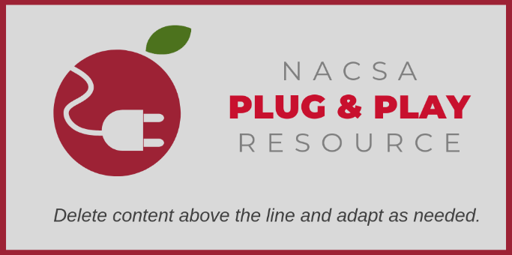
Capacity Interview Toolkit
Tool #2: Interview Preparation Form
An Interview Preparation Form helps the interview team prepare for and conduct an effective interview by distilling the most critical issues and concerns from their application review findings.
As there may not be enough time to cover everything that the team would like to address, it is important to identify priorities and ensure adequate time to address those priorities in depth.

© 2019 National Association of Charter School Authorizers (NACSA). This resource is published under a Creative Commons license, allowing noncommercial alteration and sharing, but we ask that attribute the work and link back to our site. For more information about citing or reusing this resource please see our website.

School Name:
Critical Issues Summary: [Complete this section only after completing each of the following sections.]

Part & Section | Issue/Concern | Lead Question(s) | Page Reference

Part 1: School Design
Overall, how would you rate the quality of these sections? [One sentence summary]

What are the primary questions that you would like to ask the applicant during the interview?

Part & Section | Issue/Concern | Lead Question(s) | Page Reference

Part 2: Organizational Plan
Overall, how would you rate the quality of these sections? [One sentence summary]

What are the primary questions that you would like to ask the applicant during the interview?

Part & Section | Issue/Concern | Lead Question(s) | Page Reference

Part 3: Financial Plan
Overall, how would you rate the applicant’s capacity to implement successfully the plan as proposed? [One sentence summary]

What are the primary questions that you would like to ask the applicant during the interview?

Part & Section | Issue/Concern | Lead Question(s) | Page Reference

