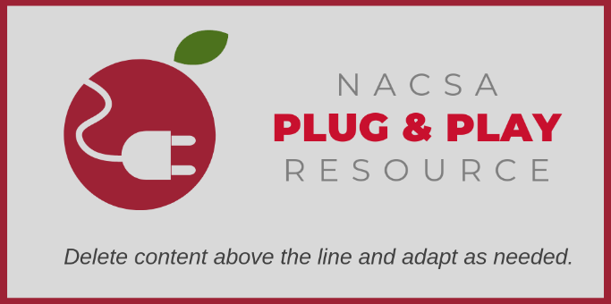
Capacity Interview Toolkit
Tool #4: Performance Tasks

A Performance Task tests the collective skills of the applicant group using scenarios that present realistic and common challenges associated with operating a charter school. Review teams should use a performance task suited to the applicants’ noted strengths and deficiencies.

© 2019 National Association of Charter School Authorizers (NACSA). This resource is published under a Creative Commons license, allowing noncommercial alteration and sharing, but we ask that attribute the work and link back to our site. For more information about citing or reusing this resource please see our website.

All performance task materials will be retained by [AUTHORIZER]. Applicants are asked NOT to discuss the tasks or materials with anyone other than their team in order to preserve the integrity of the interview process.

Thank you for your submission to the [NAME OF AUTHORIZER] request for charter proposals. In addition to a comprehensive review of your proposal, we are interested in obtaining information about your capacity with regard to operations. Please complete the performance task below, which will be scored and discussed during your interview.

Incubation Year Planning
Using the table below, outline SMART Goals for the incubation year to support the plan included in your submitted proposal, as well as interim milestones to ensure progress in the areas assigned. Please complete only the categories assigned (Note: You should be informed of which areas to focus on prior to completing this task). In the top column, note the dates at which you will evaluate progress. Please also note any assumptions you make in completing this exercise.

20[XX]-20[XX] Planning Year Milestones  (SMART Goals) by Work Stream | Benchmark Dates
Staffing & Human Resources
Student Recruitment
Services*
Contracts
Facilities

*Includes technology, transportation, food service, data management, facilities maintenance, school health and nursing and/or purchasing.

