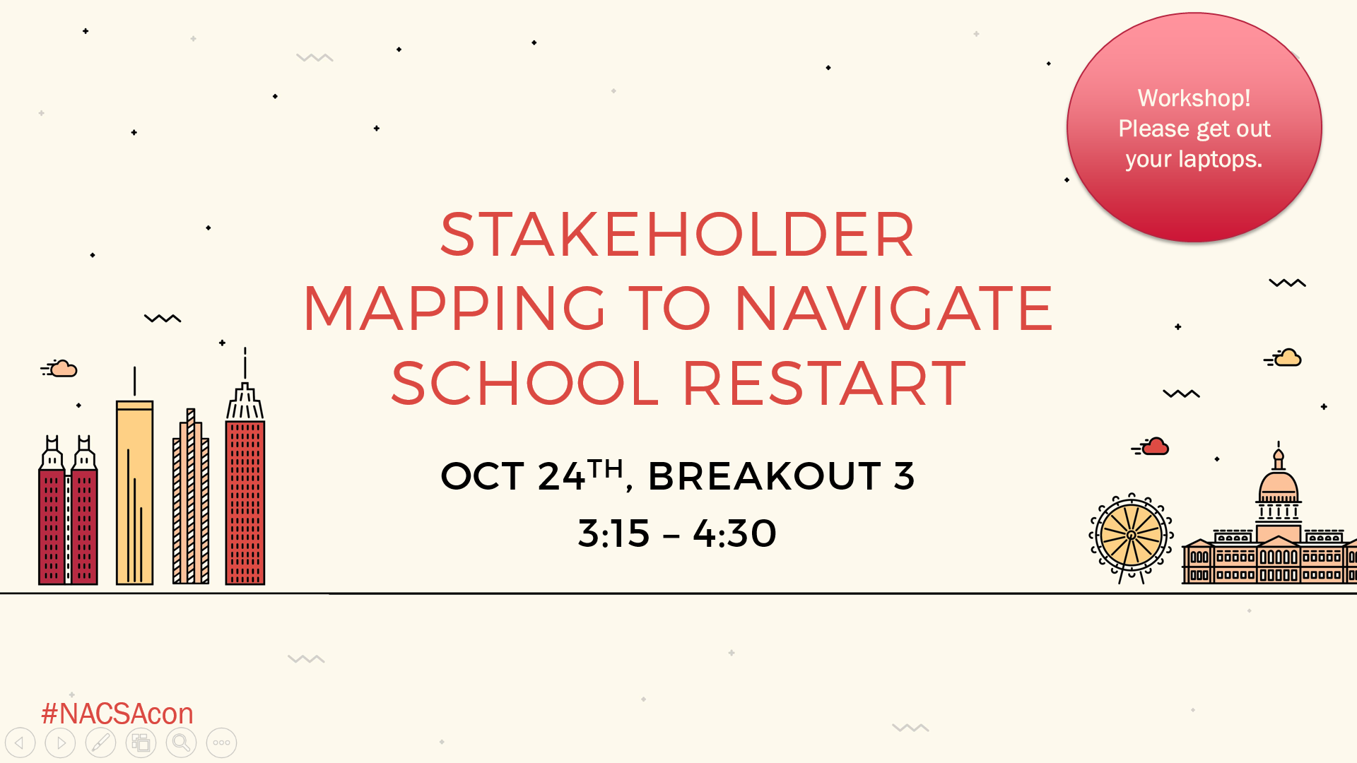

Instructions:
- Follow the prompts below to begin to create a purpose statement and then an associated stakeholder map that applies to your context.
- You may work individually, or with a partner who is familiar with your context.
- Make it as real as possible - you do not have to share what you write.

Part A: Purpose Statement (~5 min)

Develop a purpose statement around which you need to do stakeholder management. Purpose statements may exist at the organizational level (e.g., an over-arching goal of the organization) or at the project level (e.g., a specific initiative). Strong purpose statements will:
- Include a clearly stated position or desired outcome
- Provide some component of “why” you do the work
- Articulate what change is anticipated or necessary

Two sample purpose statements:
- We support mechanisms that allow parents to select excellent schools for their children, and that enable education dollars to follow each child to their school (organization level)
- Our goal is to facilitate the replacement of four chronically low-performing schools with new schools that will serve the same students as part of our school restart work (project level)

Write your purpose statement in the following box:

Self-check: Is this purpose statement clear enough that I can name stakeholders and figure out how they might position themselves for/against this purpose?

Exercise Continues on the Next Page ----->

Part B: Beginning to Map Stakeholders (~7 min)

- Populate the grid below with the key organizations/individuals that have a vested interest in your project/organization’s efforts.
- Use the notes section below the grid to explain a little about why you categorize the organizations/individuals in this way.

High Influence | Keep Satisfied: | Actively Engage:
Low Influence | Monitor: | Keep Informed:
 | Low Interest/Availability | High Interest/Availability
Notes on why organizations are located where they are (continued next page):

An actual stakeholder map will allow you to place organizations at different points along each axis to further clarify low vs. medium vs. high degrees of influence and/or interest and availability. The table above is simplified to make it easy to populate.

Visual reminder:
